|  |
| --- |
| **GUI PROGRAMMING PROJECT PHRASE 1** |
| **PROJECT NAME: Free Software Project Sharing Platform** |
| **NAME OF TEAM MEMBERS:**  **MERT FURKAN ERGÜDEN**  **SÖZ TUANA KURŞUN** |



**20.10.2020**

**PROJECT TOPIC AND NAME:** The name of our project is Free Software Project Sharing Platform. The aim of the project is to accelerate the development of free-software projects in our country and to ensure that the projects aimed to be supported can reach other developers in a short time. In this way, to increase the development of reliable and flexible applications. With the aim of the article section on the platform, to increase the opportunities to follow the mainstream such as the free software world, software and technology closely.

**DESCRIPTION**: Free Software Project Sharing Platform is a mobile based project. With this platform membership system, many developers can become members, share projects, support projects that are expected to be supported, and benefit from the articles sections of the platform and articles-documentation-related to the free software world. In addition, each member can share their own articles freely and free of sharing on this platform.

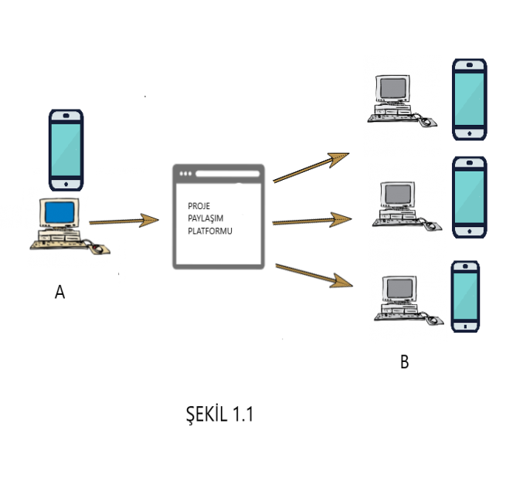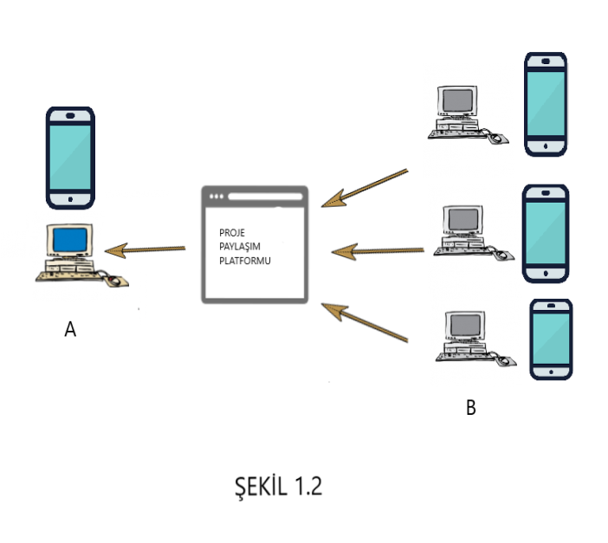

As indicated in *figure 1.1,* a project prepared in Environment A is delivered to developers in environment B on the platform. In other words, developers in environment B can contribute to the project in Environment A by using the project sharing platform.

As stated in *figure 1.2*, the project shared in environment B is delivered to the developer in Environment A on the platform. In other words, the project prepared in environment B is delivered to the developers in Environment A with the help of the project sharing platform.

Article also found on the platform, etc.in the sharing section, developers can also prepare, share and follow articles on the main topics such as free software, software, technology.

**SCENARIO**:

1. The user can log in to the application by clicking the Login or Join button.
2. After becoming a member, users will be redirected to a separate page to create their profile.
3. In this way, the information of the members will be recorded on the "my profile" page (the company they work for, the country or province they are in, other members they have contacted and the number of groups they actively develop projects, etc.).

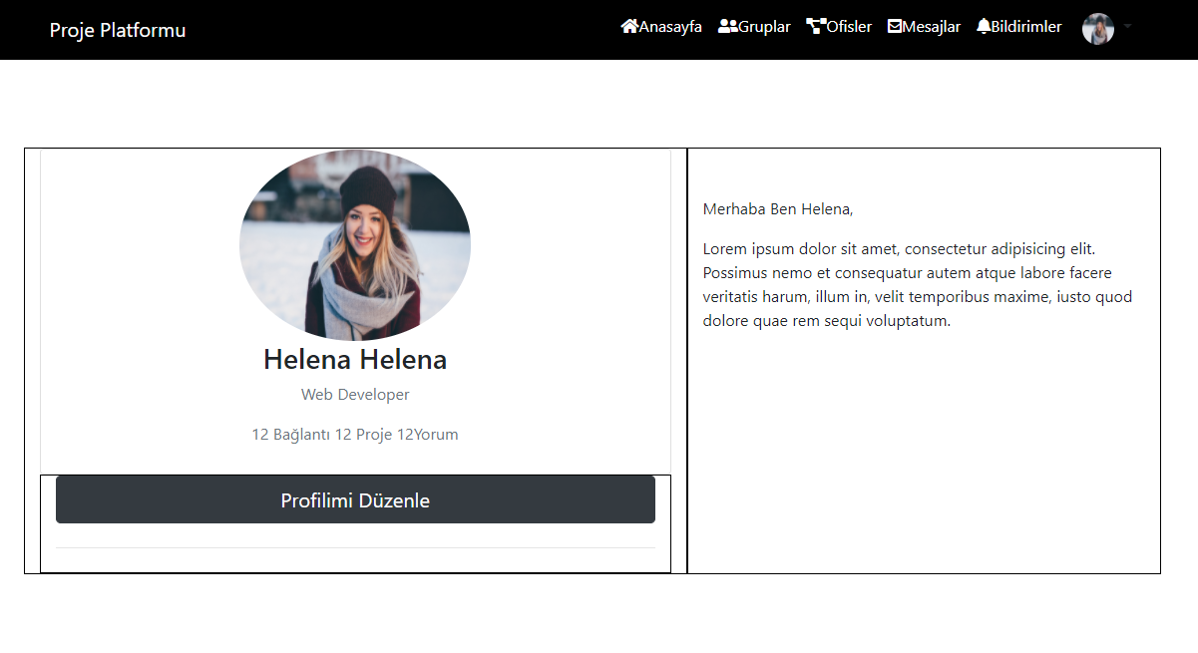

4.If the user has any ideas in mind, they can create a new project by clicking on the new project button.

5.Another option,if user wants to be a partner in a project, can also choose the group he/she wants to join according to the topics user wants to work with by clicking on the join Project button.

6. After starting the Project work, they will be able to increase the efficiency of the project by providing continuity in the project by not being disconnected from the team with the instant messaging option or online presentations within the team.

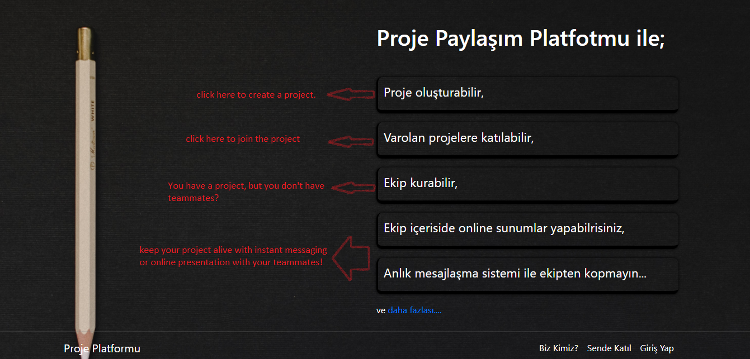

7. Profile page continuation,left banner section of the member's own notes,weather, location and to do list such as parts. In the right banner section, there are projects and articles that the member has actively initiated.

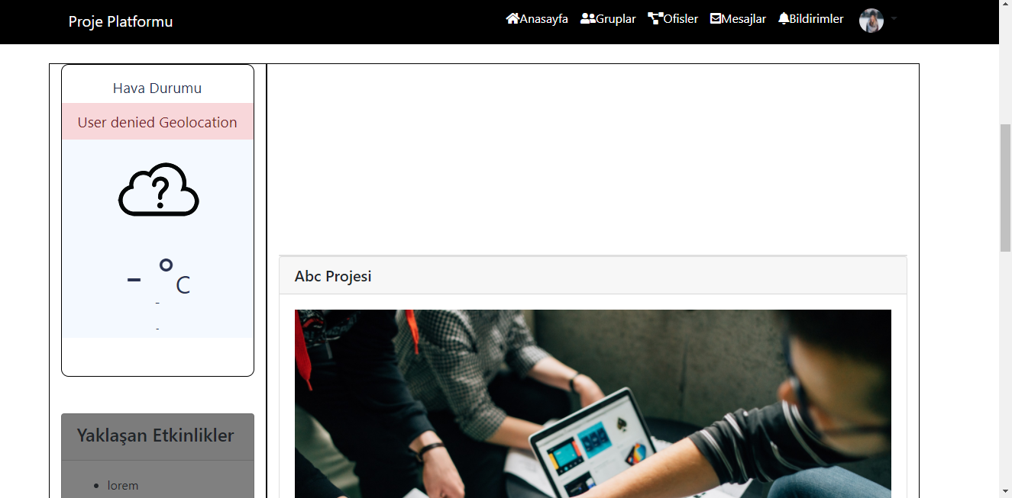

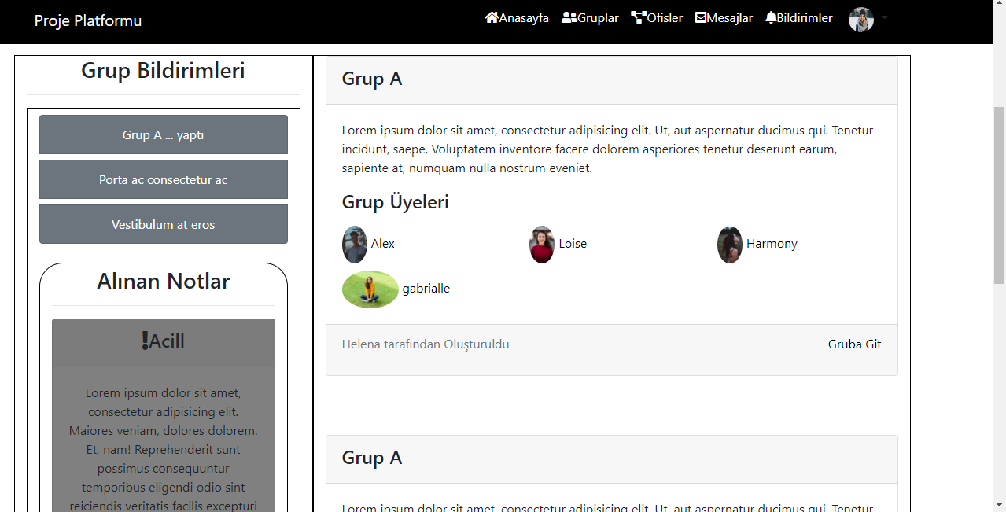

8.This figure shows the group page.

On this page, you can see the groups the member has joined, initiated groups and group movements.

**USE CASE DIAGRAM**:

1.

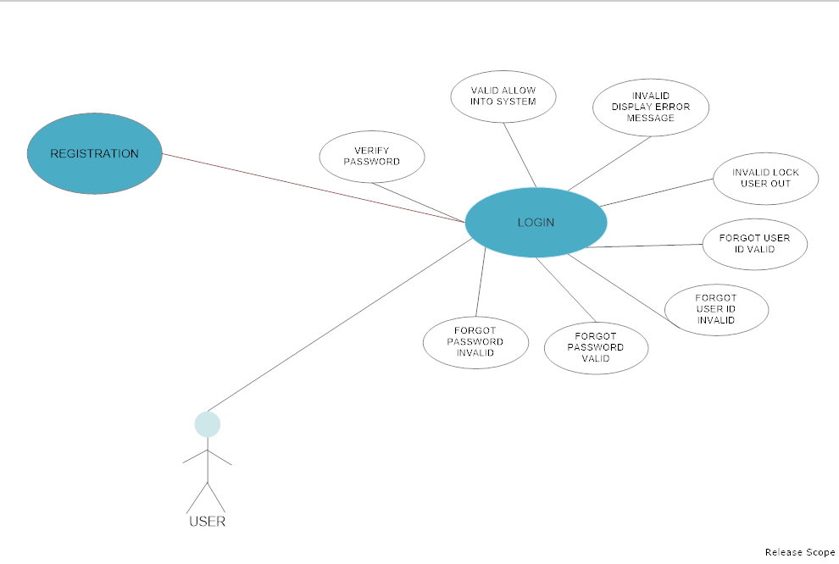

2.

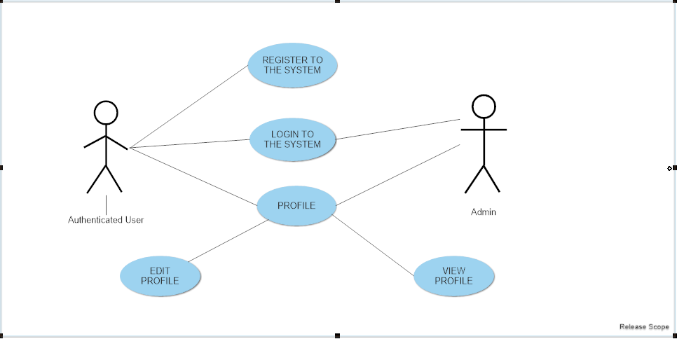

3. 